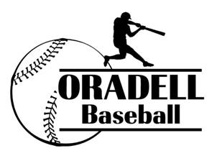Oradell Little League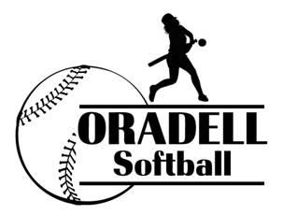
2018 Sponsorship Opportunities

Catch the fever and get ready for the 2018 Spring Little League season! There are plenty of opportunities for you or your company to support the hundreds of boys and girls who participate in Tee-ball, Baseball, Softball, or Travel Teams.

Whether you choose to sponsor a team or take out a journal ad, your participation will help ensure the season's success. As a team sponsor, your designated name will be printed on player uniforms, listed on the OLL website, and in the annual journal, which is distributed to all players and sponsors. You will also receive a commemorative plaque as a token of our appreciation (if you would like to opt-out of the plaque, please check below). We also have the added option to get a sign with your company logo and information displayed at one of our town baseball fields.

Please make your check payable to Oradell Little League and mail it along with your business card to P.O. Box 54, Oradell, NJ 07649. Company artwork can be e-mailed to eacosta@acostafirm.com. If you have any questions, please feel free to contact Erik Acosta at 973-666-0943. As always, thank you for your support of our Little League.
-------------------------------------------------------------------------------------------------------------
Team Sponsor $250 --- commemorative plaque opt-out
Field Signage (New) $150 (displayed at either Muehleck, Hoffman or Grant fields)
Ad Rates
Journal Sponsor $300 (inside cover or back cover - $150 with Team Sponsorship)
Full Page $160 ($80 with sponsorship)
Half Page $100 ($50 with sponsorship)
Quarter Page $60 ($30 with sponsorship)
Business Card $30 ($15 with sponsorship)

Name Company Name
Address
Email Phone
If you have a child is participating in the program, please list their name, age and division they will play:

Sponsorships awarded on a first-come first-serve basis.

